DELL Customer review Scraping:

Tool: Parsehub

Screen shots:

Getting the tool:

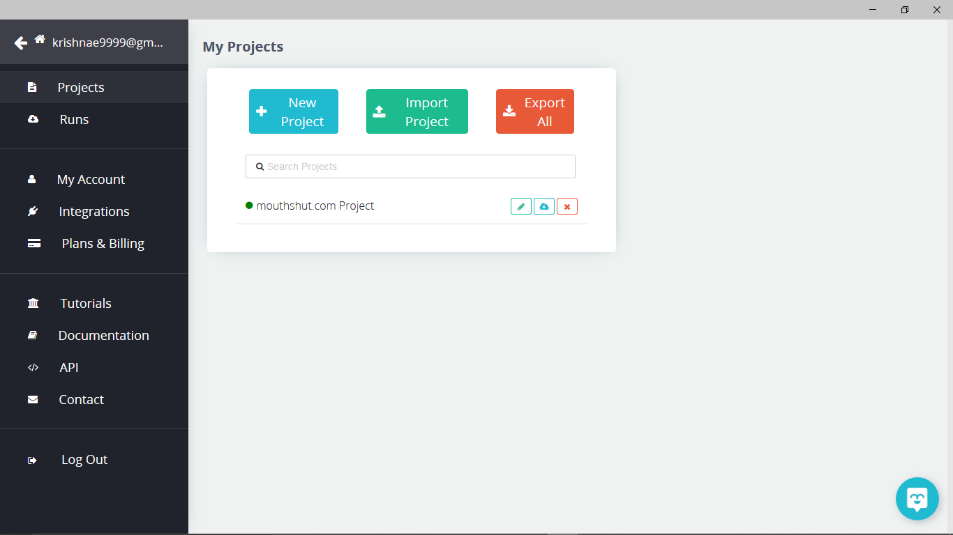

Entering the url and scraping the required data:

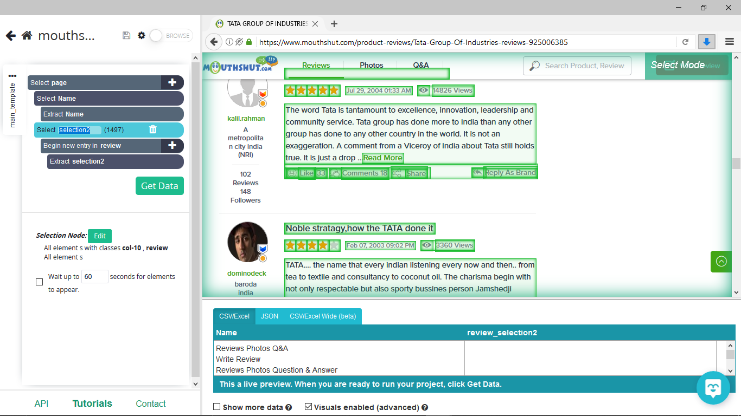

Downloading the scrapped data:

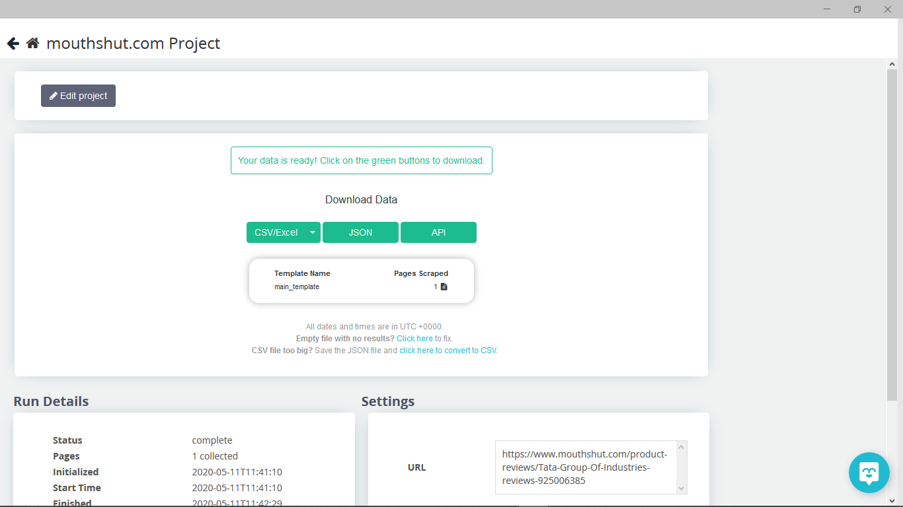

Data file:

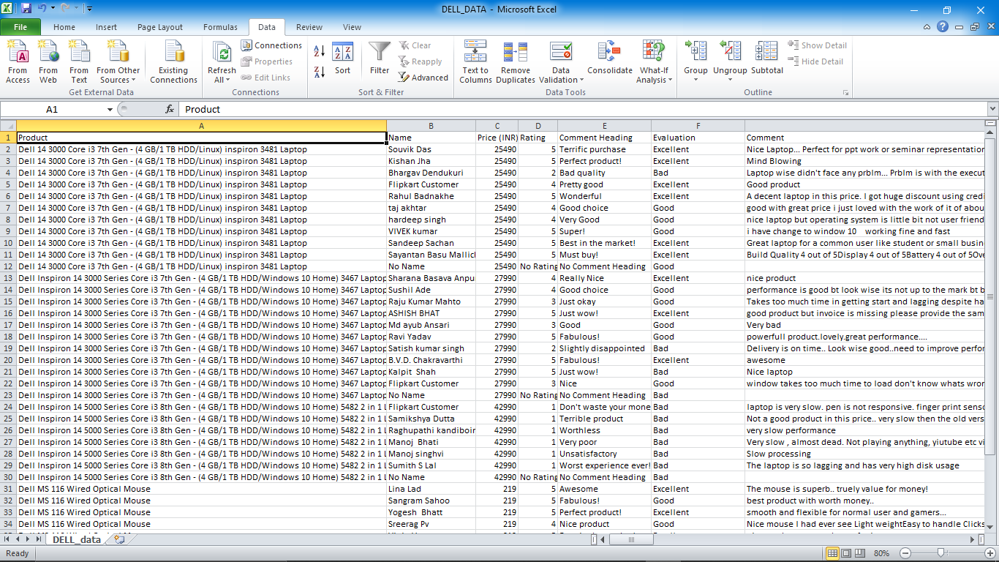

Uploading to Tableau:

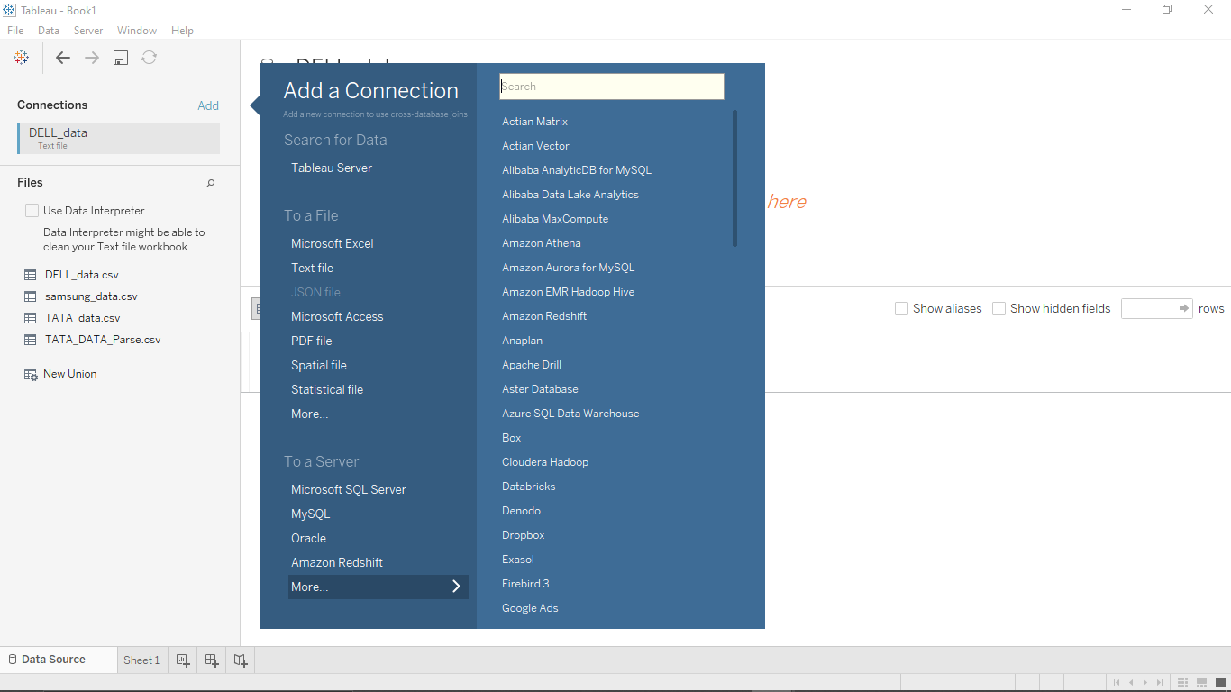

Visualization of data in Tableau:

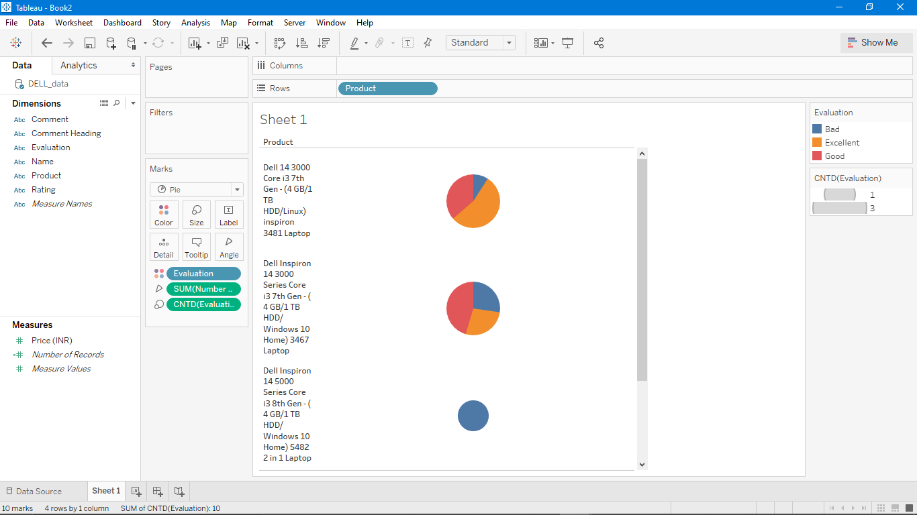

Business value depicted:

Here, in the data we had filtered it out and categorized into 3 major things. So it is much advised to the DELL company to improve their product quality in making the particular products like **Dell Inspiron 14 5000 Series Core i3 8th Gen - (4 GB/1 TB HDD/Windows 10 Home) 5482** as many of the customers seems to be unsatisfied who brought this product.